Curriculum Vitae of Bastian Nolte |  | 
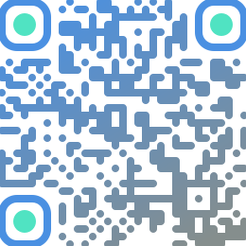 | Consultant & hands-on Architect in AI and Cloud Optimized Solutions  Enterprise full-stack Developer  Engineering Excellence Coach
Phone | DE +49 173 20 989 60  CH +41 78 252 252 1
Social Tags | Solution Driver, Connector, Innovator
Tech Tags | Robust, effective and efficient solutions including: Microsoft Azure, Internal Developer Platforms (IDP), CI/CD (GitLab, GitHub Actions), DevOps, AI Agent Teams, Claude Code Skills, Java (EE/Spring), Single Page Applications (Lit Web Components/React/Angular)
Email | business@bastian-nolte.name

Introduction
My name is Bastian Nolte. I have over 28 years of professional experience in the IT field, as a consultant, IT architect, trainer/facilitator, and software developer, as well as in project management roles with and without personnel responsibilities.
I consider myself more of a generalist and enabler than a specialist. My broad knowledge allows me to help you find and implement efficient solutions for even complex problems.
I look forward to supporting you in initiating and successfully driving change and innovation processes.
A key focus of my work is helping clients design and implement modern, reliable, and robust end-to-end solutions that optimally meet stakeholder needs. To foster innovation and productivity, I deploy cutting-edge technologies – including deep integration of AI tools, such as skilled AI agent teams.
I can help you, for example, with consulting on, designing, and implementing cloud-based solutions, single-page applications (SPAs) using Web Components, modern Java/Spring applications, and building an IDP (internal developer platform).

Abstract
In the last ten years, I have been mainly involved in projects in the insurance, industry and education sectors. My clients include companies like Capgemini Schweiz AG, ista (CK Hutchison), the Swiss Accident Insurance Fund (Suva), CSS Health Insurance, Volkswagen, Siemens, msg Systems, T-Systems and various institutions, like the Berlin State Library, the East Asian Institute, as well as various state authorities and councils.
We use agile development methods, frameworks and mechanisms, such as Scrum, LeSS, Continuous Integration, test-driven development, mob- and pair-programming, combined with process-supporting software like Atlassian JIRA and Confluence.
I possess a broad range of expertise in enterprise software architecture, enterprise development, and AI tooling, as well as in the most common programming languages and frameworks.
Although my current focus is more on consulting and hands-on architecture within the AI and cloud space, this knowledge significantly supports me in collaborating with my clients to design and implement efficient and resilient solutions.
Information
This CV is available in other versions (e.g. the "short version 'Azure'") and in the following formats: "PDF", "Web", "Word" and "Markdown". An overview of all versions and media formats can be found on the page https://bastian-nolte.name/en/resumes.
The latest version of this document can be downloaded from the web address https://bastian-nolte.name/downloads/bastian-nolte.resume.en.docx.
This document with id «docxl-f0209224ee47» was modified at Aug 21, 2026.
Table of Contents

Sector experience & expertise
 Artificial Intelligence  Insurance  Information Technology 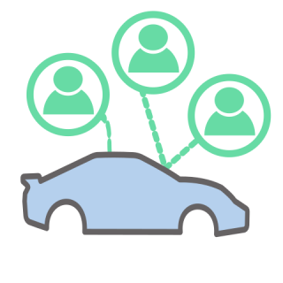 Automotive  Service Provider 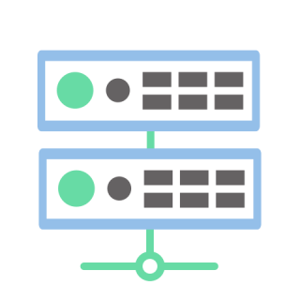 IT Service Provider  Public Service  Educational Institutions  Telecommunications  Energy Sector  IT Security

Clients


Roles
  Coach  &  Trainer |   IT  Business  Consultant |   Architect  & (Technical)  Project Lead | 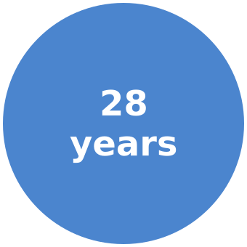  Software  Developer

Personal
Name | Bastian Nolte
Awards | Innovation Award Public Private Partnership 2009 (PPP) for the interdisciplinary use of New Media | 
IT experience since | 1998
Citizenship | Germany
Residence permit | Switzerland (permanent residence permit C)
Languages | German (mother tongue), English (C1)
Applicable | INTL (International)
Preferred region of work | Remote: International (en/de) · On site: Australia, Switzerland
Leisure activities | Surfing, Kayaking, Languages
Contact details | Lucerne | 8005 Zürich, Switzerland  Phone DE: +49 173 20 989 60  Phone CH: +41 78 252 252 1  Email: business@bastian-nolte.name  Xing: https://www.xing.com/profile/Bastian_Nolte  LinkedIn: https://www.linkedin.com/in/bastian-nolte/?locale=en_US

Preferences
(always open to new technologies)
Responsibilities / Roles | AI and cloud ready (hands-on) architecture; Consulting in AI, Azure, platform, and innovation topics
Platforms | Microsoft Azure Cloud Computing Services, Google Cloud, Kubernetes
Technologies / Frameworks | Azure Well-Architected Framework, Microsoft Cloud Adoption Framework for Azure, Java, Spring Boot, Lit (minimal-dependency single-page applications)

Soft skills
Acting on one's own responsibility | Analysing, Advising, Implementing, Checking / Testing, Improving
Myself | Introspection, Self-efficacy expectation, Personal responsibility, Self-discipline, High perceptiveness
Others | Helpfulness, Empathy, Critical faculties, Language competence
Collaboration | Team player, Flexibility, Committed, Professional competence

Project excerpts
The following chapters present my work profile to date using project extracts as examples. The presentation is in tabular form and includes my role in the respective projects, including a description of the projects, the technologies and the tools used.

Projects 2026

The Job Ledger — Agentic Opportunity CRM
Job Ledger is an AI-powered job and project acquisition solution.
In essence, the following functions were implemented
Discovery → Projects and jobs are cyclically collected from various platforms. Additionally, e-mail is supported as an input stream.
Data deduplication → Duplicates are detected and removed.
Normalization → The data from the different sources is unified.
Extraction → Requirements and general conditions are extracted and weighted [AI → Claude Haiku].
Verdict-Matching → Requirements are matched against the skill set, an FAQ and further data [AI → Claude Sonnet].
Scoring → Based on the weighting and the matching, a score is computed [deterministic / Java / Spring Boot].
Presentation → A web application shows statistics and provides listing, sorting and AI-assisted filtering of job postings and projects.
Communication → Messages in German and English can be created, managed and sent based on templates and with AI support.
Tracking → Current status, reason, note (with history).
AI Learning Loop → AI decisions such as «strictness» and «verdict» can be corrected manually. If a justification is provided, the data flows back into training. Once the regression test passes, these become part of the next release. In addition, optimised variants can be added to the «Golden Dataset».
The entire project was designed and implemented together with a team of Claude Code agents.
Details
Matching IT projects and jobs are discovered across a total of nine web platforms, deduplicated and then scored by a three-stage AI pipeline against a versioned skill profile. Incoming e-mails are processed as well.
The orchestration is a bundle of workflows in n8n, a workflow-automation engine, with PostgreSQL as the database.
Discovery takes place in specialised n8n workflows (one per platform), while general actions such as deduplication and scoring orchestration are handled centrally.
Complex tasks, including all communication with the Large Language Models, are implemented not directly in n8n but in Spring Boot services.
A central launcher cyclically starts all currently active discoverers in parallel, monitors them and logs their actions.
The assessment itself breaks down into the components «Extraction», «Verdict-Matching» and «Scoring».
In the extraction step, the requirements are extracted from the document with the help of a Large Language Model (LLM) and weighted (must/should/plus). In addition, further general conditions are read from the posting, such as the working conditions and the work location.
In the verdict-matching step, each of these requirements is checked — again using an LLM — against a versioned skill profile, and a verdict is passed (strong, met, miss).
The final «Scoring» is deterministic, based on a fixed set of rules — every result is explainable. In the first scoring step, knock-out gates filter out postings with incompatible general conditions, and missed must-have requirements cap the score. Then one score is computed for professional fit and one for the general conditions.
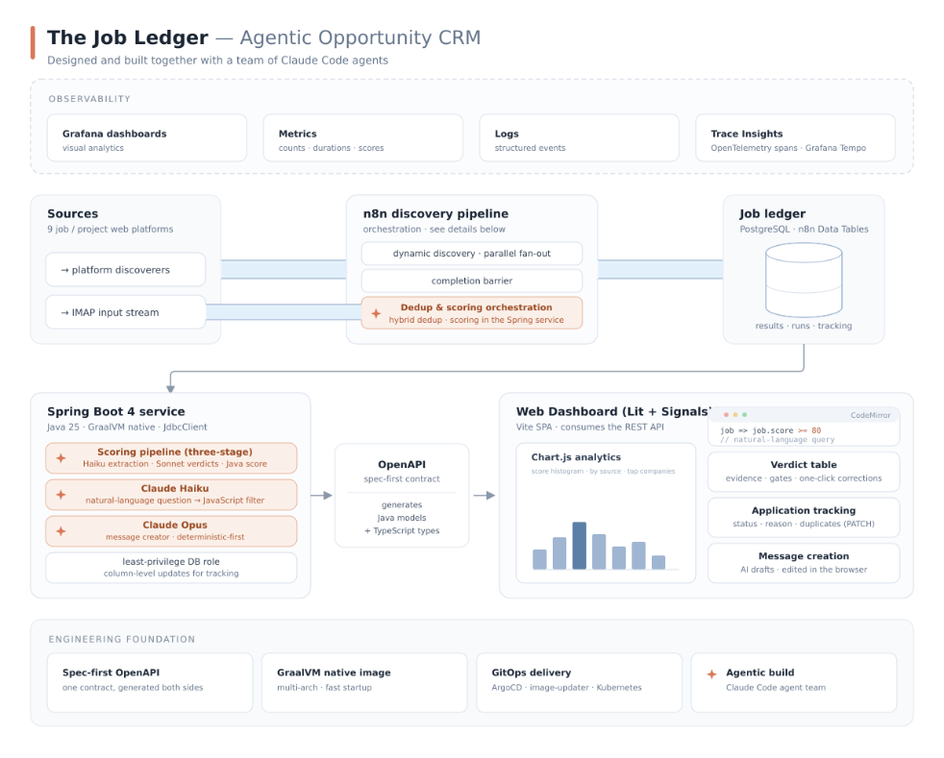
High-level system architecture.
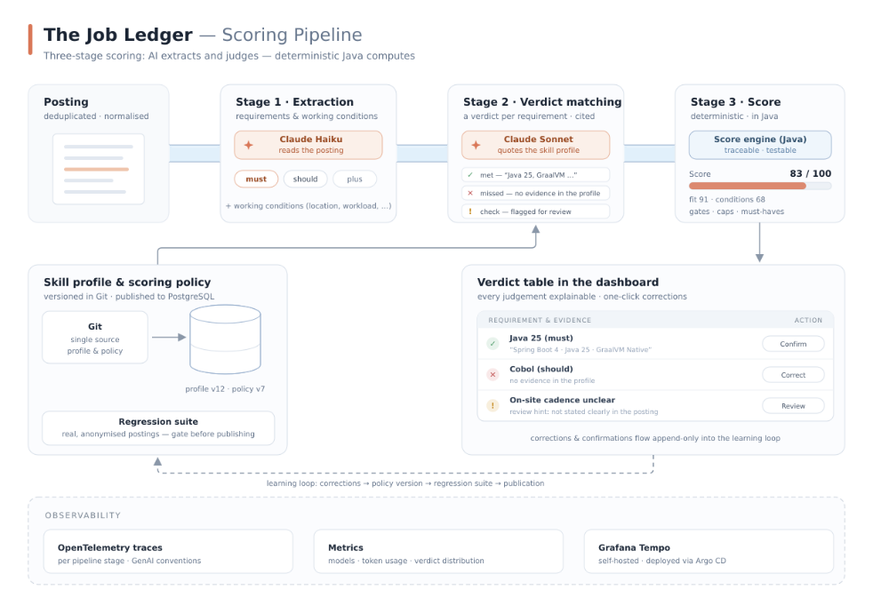
The three-stage scoring pipeline.
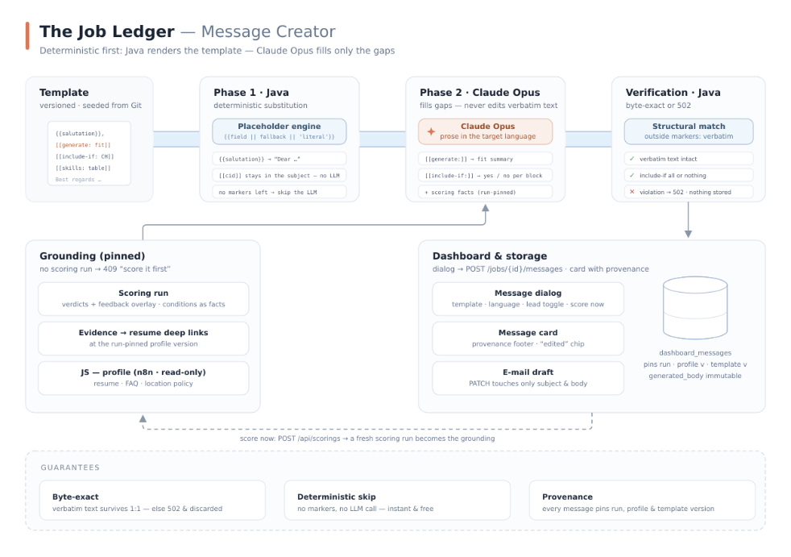
The deterministic-first message creator.
Role | Full-stack: Research, Architecture Design, Development, Test, Operating
Period | Since April 2026
Activities performed | – Planning, creation and configuration of the GitHub monorepo — path-scoped releases per subproject (semantic-release) — rebase-merge pull-request workflow — DevOps and testing  – Planning and creation of various n8n workflows, including: email inbox triage, central control workflow, discoverer, completion barrier, enricher, deduplicator and JSON-Schema validator  – Planning and creation of the REST and AI services with Spring Boot 4 and Java 25, compiled to lightweight GraalVM native images  – Design and implementation of the three-stage AI scoring pipeline: requirement extraction with Claude Haiku, verdict matching with Claude Sonnet against a versioned skill profile, deterministic score computation in Java with knock-out gates, caps and separate subscores — every verdict backed by a cited piece of evidence  – Construction of the learning loop: correction and confirmation UI in the verdict table (append-only feedback), skill profile and scoring policy versioned in Git and published to PostgreSQL, plus a regression suite of real, anonymised postings  – Observability: OpenTelemetry instrumentation per pipeline stage (GenAI conventions) and deployment of a Grafana Tempo backend via Argo CD  – Creation of a spec-first contract: an OpenAPI document acts as the single source of truth and as interface documentation. The Java models, the TypeScript types and the Contract Facts for the LLM are generated automatically from this source  – Planning and creation of the web frontend with histograms, a table, support for complex filters and a message assistant, built with minimal runtime dependencies on Google Lit + Signals and Chart.js  – Support for natural-language queries: Claude Haiku translates a free-text question into a sandboxed JavaScript filter that runs client-side and is edited in the CodeMirror editor, including sort and limit directives  – Planning and implementation of the deterministic-first message creator: Java substitutes the placeholders of versioned templates, Claude Opus fills only marked gaps and decides conditional blocks, a byte-exact structural verification discards any drift — templates without markers skip the LLM entirely  – Grounding of the message generation in the pinned scoring run — verdicts with feedback overlay, evidence as resume deep links, conditions as facts; score-on-demand and a lead-source toggle in the dialog, every stored message pins run, profile and template version  – Application tracking in the dashboard — status, reason and duplicate handling  – End-to-end tests with Vitest browser mode and Playwright; Biome for lint and format
Technologies / Products
Backend | Java, Spring Boot, GraalVM, PostgreSQL (Postgres)
Frontend & Dashboard | TypeScript, Lit, Lit Signals (@lit-labs/signals), Vite, Chart.js, CodeMirror
Orchestration & AI | n8n (Workflow automation platform), pandoc (Universal document converter), OpenAPI, Claude AI, Claude Sonnet, Opus, Haiku, etc.
Quality & Tooling | Vitest, Playwright, Biome (Biome linter, Biome formatter), pnpm, semantic-release (semantic-release-monorepo), Claude Code, Claude Agent Teams
Infrastructure & DevOps | Docker, Kubernetes (k8s), Kustomize, Traefik, cert-manager, SealedSecrets (Bitnami Sealed Secrets), Grafana, Grafana Tempo, OpenTelemetry (OTel), GitHub Workflows/Actions, Argo CD, Cloudflare Tunnels, Cloudflare Access

Agentic Inbox Triage for Job and Project Mail
n8n workflow hosted on an on-premise Kubernetes cluster that triages inbound business mail end to end. Each message is split into body and PDF / DOCX attachments, normalised to Markdown text through dedicated extractor nodes, and passed through a three-stage Claude Haiku chain: classification into job offer, project request, or noise; a fit-check against the resume Markdown returning a structured accept / decline / clarify verdict; and a tailored draft reply parked for review rather than sent automatically (human in the loop). Matched messages are filed into a dedicated IMAP folder. Authored using a Claude Code Agent Team against the n8n MCP server and deployed behind Cloudflare Tunnel and Access.
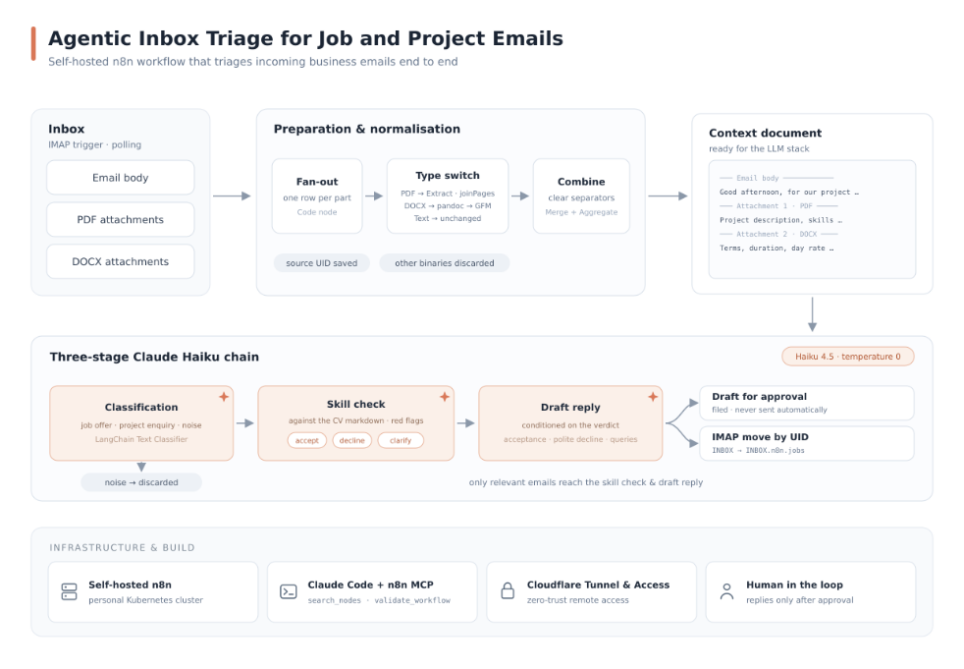
High-level architecture of the inbox-triage workflow.
Role | Architecture, Development, Operations
Period | June 2026 - June 2026
Activities performed | – Three-stage Claude Haiku chain on every incoming mail: classification into job offer / project request / noise, a fit-check against the resume Markdown returning a structured accept / decline / clarify verdict, and a tailored draft reply parked for review  – IMAP trigger polling a personal mailbox; a JavaScript Code node fans each message out into one row per body plus one row per PDF / DOCX attachment, drops unsupported binary types and preserves the source UID for later filing  – Attachment normalisation: a Switch routes by file type — PDFs via the Extract-From-File node with joinPages, DOCX via a Code node that shells out to pandoc and emits GitHub-Flavoured Markdown, plain bodies pass through  – Merge + Aggregate recombine bodies and attachment text into a single context document with clear separators, ready for the LLM stack  – LangChain Text Classifier node backed by Claude Haiku 4.5 at temperature 0, with a discard branch for the noise category so only relevant mail proceeds  – Fit-check stage loads the resume Markdown as context and returns a structured verdict (accept / decline / clarify) plus surfaced red flags before any draft is generated  – Reply-draft stage conditions on the fit verdict, produces an acceptance, polite decline, or targeted clarifying questions, and parks the draft for review rather than sending it directly  – IMAP MoveEmail node files matched messages from INBOX into a dedicated INBOX.n8n.jobs folder by UID, keeping the inbox clean  – Workflow authored from Claude Code against the n8n MCP server (search_nodes, get_node_types, validate_workflow) and deployed onto a self-hosted n8n instance behind Cloudflare Tunnel and Access
Technologies / Products
Workflow & AI | n8n (Workflow automation platform), LangChain.js (LangChain), Claude AI, Claude Sonnet, Opus, Haiku, etc., Claude Code
Languages & Adapters | JavaScript (ECMAScript, ES), Node.js® (node), pandoc (Universal document converter), IMAP (Internet Message Access Protocol)
Infrastructure | Kubernetes (k8s), Cloudflare Tunnels, Cloudflare Access

Resume Website & AI Chatbot
Migration of this resume website from Gatsby to Next.js using a Claude Code Agent Team, followed by the design and implementation of an AI-powered resume chatbot. The chatbot uses Claude Haiku via the Anthropic API with streaming SSE responses, letting visitors ask questions about professional background, skills, and experience.
Role | -
Period | April 2026 - April 2026
Activities performed | – Framework research and selection  – Develop a project-specific CLAUDE.md file  – Creation of a Claude Code Skill allowing Claude to maintain this resume's references efficiently  – Carrying out the migration using a Claude Code Agent Team.  – Design and implementation of an AI chatbot as a React widget with streaming responses  – Development of a Netlify serverless function as chatbot backend using Claude Haiku, and rate limiting  – Building a markdown generator to provide chatbot context  – Building a Microsoft Word generator (.docx) that mirrors the complex PDF document (table of contents, headings, multicell tables, images) — using the docx TypeScript library  – Accessibility and responsiveness of the chat widget (ARIA roles, keyboard navigation)
Technologies / Products
 | Next.js (NextJS), Claude AI, Claude Code, Claude Agent Teams, Claude Code Skills, Retrieval-Augmented Generation (RAG), React (reactjs), Sassy CSS (SCSS, SASS), HTML5 (HTML), CSS, TypeScript, JavaScript (ECMAScript, ES), TSX (Typed JSX), JSX, JavaScript Object Notation (JSON), JSON Schema, YAML Ain’t Markup Language (YAML), TOML (Tom's Obvious, Minimal Language), Scalable Vector Graphics (SVG, skalierbare Vektorgrafik), Latex, TeX Live, Microsoft Word, docx (docx TypeScript library), netlify, Git, Github, GitHub Workflows/Actions, Docker, continuous integration, continuous delivery, JetBrains IntelliJ IDEA, Google Analytics, Jamstack, PRPL pattern (Push (or preload), Render, Pre-cache, Lazy Load), pnpm, Jest (JavaScript testing framework), Jest Snapshots (Jest Snapshot Testing), Claude Sonnet, Opus, Haiku, etc., Anthropic TypeScript SDK (@anthropic-ai/sdk), Framer Motion, Kubernetes (k8s), Grafana, PostgreSQL (Postgres), Argo CD, cert-manager, Cloudflare Tunnels, Cloudflare Access, Mend Renovate (Renovate, Renovate Bot)

Language Learning App with Lit and Web Components
Designed and implemented together with a Claude Code Agent Team: A modern language learning application built on native Web Components with only two production dependencies. Features include 3D flip animations, keyboard-first interaction, reactive state management, localisation, and design template support.
Role | Research, Architecture, Development
Period | Since March 2026
Activities performed | – Design and implementation of a component-based architecture using Lit and Shadow DOM  – Reactive state management with TC39 Signals and computed properties  – Implementation of 3D card flip animations with CSS transforms  – Keyboard-first user experience with shortcut system  – Persistent learning progress via localStorage  – Minimal dependency architecture with only two production dependencies, reducing bundle size and supply-chain risk  – Internationalisation with @lit/localize and XLIFF-based translation workflow  – Code quality assurance with Biome 2 for linting and formatting, TypeScript strict mode for static type checking, and Git pre-commit hooks for automated quality gating
Technologies / Products
 | Lit, Web Components, TC39 Signals, Vite, TypeScript, pnpm, Biome (Biome linter, Biome formatter), Claude AI, Claude Code, Claude Agent Teams, Mend Renovate (Renovate, Renovate Bot)

Surf Session Scheduler
Real-time surf session availability tracker that scrapes session data from a booking platform, caches it with a two-tier strategy (Caffeine + GCS), and pushes live updates to connected single page applications via WebSocket. The Spring Boot 4 backend compiles to a GraalVM native image for fast cold starts on Google Cloud Run, while the React/TypeScript frontend uses shadcn/ui components with responsive calendar and list views. Deployed to both on-premise Kubernetes (ArgoCD, Traefik) and Google Cloud Run via multi-architecture CI/CD pipelines.
Role | Architecture, Development, DevOps
Period | January 2026 - February 2026
Activities performed | – Design and implementation of a Spring Boot 4 backend with WebSocket push and event-driven cache refresh  – Parallel external booking API fetching via CompletableFuture and Virtual Threads  – Two-tier caching with Caffeine (in-memory, TTL-based) and optional GCS persistence for scale-to-zero scenarios  – Compilation as GraalVM native image for minimal startup time and reduced memory footprint  – Development of a React/TypeScript frontend with shadcn/ui, Tailwind CSS and Framer Motion  – Real-time data synchronisation via WebSocket with automatic reconnection on tab switch (Visibility API)  – Responsive rendering as calendar and list views with device and orientation detection  – Multi-architecture CI/CD pipelines (amd64 + arm64) with GitHub Actions and Semantic Release  – GitOps deployment on k3d Kubernetes via ArgoCD, Kustomize, Traefik ingress and cert-manager  – Parallel deployment on Google Cloud Run with GCS cache persistence and Stackdriver metrics
Technologies / Products
Backend | Java, Spring Boot, Spring Framework (Spring), GraalVM, Gradle Build Tool, Java API for WebSocket, Nginx
Frontend | React (reactjs), TypeScript, Vite, Tailwind CSS, shadcn/ui, Framer Motion, Node.js® (node)
Infrastructure & DevOps | Docker, Kubernetes (k8s), Argo CD, Kustomize, Traefik, cert-manager, Cloudflare Tunnels, Cloudflare Access, GitHub Workflows/Actions, Google Cloud, Google Cloud Run, Grafana, Mend Renovate (Renovate, Renovate Bot)

ista Corporate (part of CK Hutchison Group)
(Oktober 2022 – Januar 2026)
ista is an international building management technology company operating in 20 countries with over 6,300 employees. Specialising in energy efficiency and CO₂ reduction for residential and commercial properties, ista manages data and digital processes for more than 460,000 customers across approximately 14 million properties worldwide (as of January 2026).

Azure Cloud Consulting & Software Craftsmanship Coaching
Follow-up project
Azure cloud consulting and software craftsmanship coaching for one of the world's biggest Microsoft Azure clients.
Role | Azure Cloud Consulting, Software Craftsmanship Coaching
Period | July 2025 - January 2026
Activities performed | – Consulting in Azure architecture and cloud best practices  – Support the international group's central Azure cloud solutions team in architecture and consult on implementing central top-notch Azure cloud solutions  – Conducting training courses and workshops on code quality, test-driven development in the infrastructure environment, and cloud architectures

Enterprise-wide Azure Cloud Platform
As the central Azure cloud solutions team of an international corporation with companies in 20 countries (energy sector), we designed and developed the central cloud platform for the entire group, with hundreds of subscriptions and tens of thousands of Azure resources.
In doing so, we followed the «Azure Well-Architected Framework» and the «Microsoft Cloud Adoption Framework for Azure».
Besides the technical implementation, we focused on the organisational aspects of cloud adoption, such as governance, security, and compliance.
Our team worked closely with our company's solutions architects, the IPD team (internal developer platform) and the lift and shift team to help them implement state-of-the-art solutions and ensure a smooth transition of the on-premises services to the Azure cloud.
In addition to my work in that cloud team, I supported our stakeholders in solving more complex problems and provided training to employees, mainly on Azure cloud technologies and in code quality, best practice patterns, domain-driven design (DDD) and test-driven development (TDD).
Role | Hands-on Cloud Architect, Cloud Engineer, Training Consultant
Period | September 2022 - June 2025
Activities performed | – Designed and implemented the group's central Azure Solutions  – Evolved the Azure Cloud Solutions Platform based on security, compliance, and governance requirements  – Consulted our stakeholders on how to implement solutions, in consideration of governance and compliance, and following best practices patterns  – Planned and configured complex CI/CD pipelines for the provision of infrastructure and applications on Azure; day-to-day collaboration ran through GitLab merge-request workflows with code reviews.  – Trained colleagues, mainly in relation to architecture and development best practices  – Supported our stakeholders in analysing and solving problems in the Azure Cloud
Technologies / Products
Architectural frameworks | Azure Well-Architected Framework, Microsoft Cloud Adoption Framework for Azure, Azure Landing Zone Architecture, Azure Architecture Center, Security baselines for Azure, Azure FinOps
Governance & Security | Microsoft Entra ID (formerly Azure Active Directory), Tenable cloud security, Azure Policy, Microsoft Entra Privileged Identity Management (PIM), Microsoft Azure Security Center, Microsoft Defender for Cloud, Microsoft Sentinel, Azure Firewall Policy, Azure Monitor (Log Analytics), CIS Hardened Images (Virtual machine (VM) images)
Central services | Azure Dashboard Hub, Azure Dashboard, Azure Firewall Premium, Azure Application Gateway, Azure Web Application Firewall, Azure Public DNS, TLS Certificates, Azure Compute Gallery, Azure Communication Services, Azure Virtual WAN, Azure ExpressRoute, Azure VPN Gateway, Azure Kubernetes Service (AKS), Kubernetes (k8s), Grafana, PostgreSQL (Postgres)
Landing Zones | Azure Subscription, Azure Management Groups, Azure Backup vaults, Terraform Modules, Azure Virtual Network (vNET), Azure virtual network traffic routing, Azure User-Defined Route (UDR), Azure Network security group (NSG), Azure Private Link, Azure Private Endpoint, Azure Private DNS Zone, Azure Key Vault
Build Toolchain | GitLab, Argo CD, Crossplane, Terraform (infrastructure as code software, IAC), PowerShell (PowerShell Core), Pester (PowerShell testing framework), Azure Resource Manager (ARM), Azure Resource Manager templates (ARM templates), Bicep, JFrog (JFrog Platform, JFrog Artifactory), Mend Renovate (Renovate, Renovate Bot), MkDocs, Microsoft Copilot, Claude AI, Claude Code, Claude Code Skills, Claude Agent Teams, ChatGPT

Azure Data Aggregation & Curation Solution
Planning, implementation and operation of a data aggregation & curation application using Microsoft Azure Cloud Computing Services
Role | Full Stack (Analysis > Architecture >> DevOps: Development > Deployment > Operations)
Period | July 2021 - June 2022
Activities performed | – Planning of the entire solution  – Elaboration of a solution architecture  – Building source code management as a monorepo with Yarn Workspaces  – Azure Enterprise Integration Platform as a Service  – Identity and access management with Azure Active Directory  – Implementation of a web application with Vue.js, Azure Static Web Apps and Azure Function Apps  – Azure Function Apps for scraping, aggregation, curation and sending to Slack channels  – Azure Cosmos DB for data storage  – Propagation of business events via Azure Event Grid (event-driven architecture)  – Slack App, Slack Block Kit for messaging  – Provisioning infrastructure via Azure Resource Manager and Bicep  – Continuous Integration and Continuous Deployment with Azure DevOps Services
Technologies / Products
Microsoft Azure Cloud Computing Services | Azure Active Directory (Azure AD), Azure API Management, Azure Function Apps, Azure Durable Function Apps, Azure Cosmos DB, Azure Event Grid, Azure Monitor, Azure Resource Manager (ARM), Azure Resource Manager templates (ARM templates)
Client / Frontend (SPA) | Vue.js, Pinia, HTML5 (HTML), CSS, axios
Backend | OpenAPI, TypeScript, axios, XPath
Build Toolchain | Azure DevOps Services, Terraform (infrastructure as code software, IAC), Node.js® (node), PowerShell (PowerShell Core), Yarn - Package Manager
Tools for test-driven development | Jest (JavaScript testing framework), Cypress (JavaScript End to End Testing Framework)
Development Environments & Tools | Microsoft Visual Studio Code (VS Code), Azure Functions Core Tools, Postman

A platform for brokering tickets of Swiss attractions
This project was about planning and implementing a platform for the central distribution of tickets of Swiss attraction providers via a common it-platform. In addition to offering tickets, we implemented features such as weather information, opening hours, ride times, and billing.
In this startup project, I had a multifunctional role. Initially, I was mainly involved in consulting and training to then subsequently support the setup of an Azure cloud environment and the development of the overall solution (hands-on).
In the beginning, I provided training on process models from project organization, such as SCRUM and Kanban. Then, in joint workshops, we evaluated which software best met our requirements. We then set up this software together and integrated its use into our daily processes.
After introducing essential tools such as Atlassian Jira, Confluence, Mural and Zoom, we moved towards more development-related topics.
In the second phase, we continued to build understanding and technical foundations for agile software development in workshops. Topics included continuous integration and deployment, the test pyramid, and code quality topics such as SOLID, TDD, mob and pair programming, and KISS.
In the third phase, we jointly designed and implemented a minimum marketable product (MMP). We built the development and integration environments, configured and provisioned the Azure cloud resources and performed the software development. In the grid below, you will find information on the technologies used.
Role | Multifunctional role (consulting, teaching, hands-on)
Period | September 2019 - December 2020
Activities performed | – Consulting  – Training  – Introduction CI/CD with Azure DevOps  – Introduction Azure Cloud Computing  – Hands-on development of the MMP
Technologies / Products
Microsoft Azure Cloud Computing Services | Azure Active Directory B2C (Azure AD B2C), Azure Function Apps, Azure Durable Function Apps, Azure Web Apps, Azure SQL Database, Azure Monitor, Azure API Management, Azure Event Grid, Azure Service Bus
Client / Frontend | Angular, Angular CLI, NgRx (reactive state for angular), RxJS, Angular Material, HTML5 (HTML), CSS
Backend | OpenAPI, .NET 6 (.NET Core), F#, C#
Build Toolchain | Azure DevOps Services, Github, Azure Resource Manager (ARM), Azure Resource Manager templates (ARM templates), Bicep, Node.js® (node), PowerShell (PowerShell Core)
Tools for test-driven development | Karma Test Runner (Karma), Protractor end-to-end test framework (Protractor), Jasmine Modultest-Bibliothek (Jasmine), TSLint
Development Environments & Tools | Microsoft Visual Studio Code (VS Code), Azure Functions Core Tools, Figma, NuGet, Yarn - Package Manager

Curriculum Vitae
Planning and implementation of this Curriculum Vitae / Résumé website.
Role | Full Stack (Analysis > Architecture > Development > DevOps)
Period | November 2020 - February 2021
Activities performed | – Planning of the new résumé page  – Solution architecture design  – Research and selection of technologies to be used  – Texts & (vector) graphics creation  – Setting up Continuous Integration  – Setting up Continuous Deployment  – Implementation of website & PDF generation…  – …from a «single source of truth»  – …based on state-of-the-art technologies (Gastby Static Site Renderer, HTML-5)  – Rollout and operation
Technologies / Products
 | Gatsby (gatsbyjs, Static Site Renderer), React (reactjs), Sassy CSS (SCSS, SASS), HTML5 (HTML), CSS, TypeScript, JavaScript (ECMAScript, ES), TSX (Typed JSX), JSX, JavaScript Object Notation (JSON), JSON Schema, YAML Ain’t Markup Language (YAML), TOML (Tom's Obvious, Minimal Language), Scalable Vector Graphics (SVG, skalierbare Vektorgrafik), Open Graph protocol, GraphQL, Latex, TeX Live, netlify, Git, Github, Docker, continuous integration, continuous delivery, Azure DevOps Services, JetBrains IntelliJ IDEA, Google Analytics, Jamstack, PRPL pattern (Push (or preload), Render, Pre-cache, Lazy Load)

CSS Insurance
(2018 - 2020)
CSS Insurance is not just a health insurance company but an insurance company for every situation in life. When it comes to health, around 1.7 million people place their trust in CSS. Its wide range of products includes health, accident and property insurance.

Excellence and Innovation
Consultant and trainer for innovation, as well as software excellence and craftsmanship
From 2018 to 2020, I supported CSS Insurance in various areas. I promoted the further development of employees in my stream towards even more excellence and know-how by planning and conducting training and workshops on excellence and innovation topics.
I also supported and actively participated in introducing mob and pair programmings, mainly on software craftsmanship and software excellence.
Furthermore, I supported the client in the development areas of front-end and back-end development and DevOps to initiate the transition into the world of cloud computing.
I helped my SCRUM teams analyse concrete problems, find solutions and implement them while adhering to best practices, and provided advice to the teams and lead architects of my stream.
Role | Consultant and trainer for excellence and innovation topics
Period | October 2018 - June 2020
Activities performed | – Conducted workshops and training:  – Software Development in the Mob "Methodology and Implementation".  – Coding Dojos on various software craftsmanship topics and excellence topics, such as test-driven development (TDD), clean code and SOLID principles.  – Introduction to Domain-driven Design (DDD)  – Fullstack development under MacOS  – The basics of the programming language Kotlin  – Programming with "observable streams" and ReactiveX  – High-performance microservices with Quarkus and GraalVM  – Introduction to Docker and Kubernetes  – Continuous Integration with Microsoft Azure DevOps Pipelines  – Introduction to Microsoft Azure Cloud  – Front-end development in Angular, React, Vue.js with Flow/Redux/NgRx and Immutables
Technologies / Products
Client / Frontend | React (reactjs), JSX, Vue.js, Angular, TypeScript, Apache Cordova, HTML5 (HTML), CSS, Sassy CSS (SCSS, SASS), JavaScript (ECMAScript, ES), JavaScript Object Notation (JSON), Material Design
Client Build Toolchain | npm, Node.js® (node), TeamCity CI/CD
Middleware / Backend | Kotlin, Java Platform, Enterprise Edition (JEE), Microsoft Azure, in detail:: Quarkus (Supersonic Subatomic Java), GraalVM, Enterprise JavaBeans (EJB), Java Persistence API (JPA), Java Transaction API (JTA), Java Named Queries (JPA Named Queries), Java Message Service (JMS), Java API for XML Web Services (JAX-WS), Java API for RESTful Web Services (JAX-RS), Contexts and Dependency Injection (CDI), IBM WebSphere Application Server (WSA), Airlock Web Application Firewall (WAF), Apache Commons, Apache Collections, Apache Log4J (Log4J), Simple Logging Facade for Java (SLF4J), Java Authentication and Authorization Service (JAAS), SQL, PL/SQL, Microsoft Azure Cloud Computing Services (Microsoft Azure)
Server Build Toolchain | Apache Maven (Maven), TeamCity CI/CD
Tools for test-driven development | code quality tools & continuous delivery & version control: SonarQube, Lint, Docker, Azure DevOps Services, Git, Atlassian Bitbucket (Bitbucket, Stash), Github, Splunk  Server: Arquillian, H2 Database Engine (H2), JUnit, Mockito, PowerMock, Hamcrest  Client: Karma Test Runner (Karma), Protractor end-to-end test framework (Protractor), Jasmine Modultest-Bibliothek (Jasmine), Selenium Grid (Grid), Jest (JavaScript testing framework)
Development environments & tools | JetBrains IntelliJ IDEA, Oracle SQL Developer, Postman, MacOS, Microsoft Windows 10 (Windows 10)
Agility toolchain | Atlassian Jira Server (Jira), Atlassian Confluence (Confluence), Atlassian Bitbucket (Bitbucket, Stash)

SUVA Accident Insurance
(09/2015 - 12/2017)
From September 2015 to December 2017, I was involved in various projects at Swiss Accident Insurance Fund (Suva).
The Swiss Accident Insurance Suva is an essential part of the Swiss social security system. As an independent company under public law, Suva insures people at work and in their leisure time. Its prevention programmes in occupational and leisure safety prevent accidents and occupational illnesses, promote a safety culture in companies, raise awareness of hazards, and motivate people to take personal responsibility.
In the following chapters, I will break down the projects I was able to accompany at Suva.

Risk Pricing
In the RiskPricing programme, the processes for premium assessment and the systems for setting premium rates were redeveloped, taking into account the industry, risk community, bonus-malus and experience rating, and new large claims and reinsurance solutions were also implemented.
A solution was created for analysing the current risk situation and the financial situation, taking into account information from the risk information system and the adcubum SYRIUS insurance software, based on which the premium situation can be assessed and the reduction of compensation reserves calculated.
With the inclusion of the bonus-malus models and the experience rating, simulations can be carried out to set the premium rates in occupational accident and non-occupational accident insurance lines. In addition, the calculation and creation of the basic sheets and the generation of the raw data for digital printing in the context of customer communication take place in the newly created system.
Role | Application architect and lead developer in a SCRUM team with 8 developers
Period | October 2016 - December 2017 (worked at suva since 2015)
Activities performed | – Support the Scrum Master and the solutions architect in the rough estimation of the project effort and identify possible project risks.  – Advise the project manager and the project owner about conceivable implementation variants of the requirements from the technical concepts.  – Data modelling of the application part of the "grundlagenblatt" calculation (the injurance policy).  – Design and implementation of the prototype as a proof of concept, as well as significant parts of the application, especially the reusable components, both in frontend and backend.  – Training of team members on Java (especially the Streaming API and Lambda Expressions), Java Enterprise Edition and in the use of modern web technologies (especially TypeScript and Angular). Imparting knowledge on the use of modern toolchains, especially for the realisation of test-driven development (in detail the implementation and execution of module, integration and e2e tests), as well as on continuous development and delivery.
Technologies / Products
Client | HTML5 (HTML), CSS, Sassy CSS (SCSS, SASS), Angular, TypeScript, JavaScript (ECMAScript, ES), Angular UI Grid, JavaScript Object Notation (JSON), RESTretto-Framework, Apache HTTP Server
Client Build Toolchain | npm, Node.js® (node), Jenkins (Hudson)
Middleware / Backend | Java Platform, Enterprise Edition (JEE) und Java SE, in detail:: Enterprise JavaBeans (EJB), Java Persistence API (JPA), Java Transaction API (JTA), Java Named Queries (JPA Named Queries), Java Persistence Query Language (JPQL, Jakarta Persistence Query Language), Java Message Service (JMS), Java API for XML Web Services (JAX-WS), Java API for RESTful Web Services (JAX-RS), Contexts and Dependency Injection (CDI), Expression Language (EL), Aspose Cells, Aspose PDF, Aspose Words, Oracle WebLogic Server (WLS), Oracle Service Bus, Airlock Web Application Firewall (WAF), Apache Commons, Apache Collections, Apache Log4J (Log4J), Simple Logging Facade for Java (SLF4J), YAML Ain’t Markup Language (YAML), Apache DeltaSpike, Java Authentication and Authorization Service (JAAS), JSON Web Token (JWT), Kerberos, Single Sign-on (SSO), RESTretto-Framework, Web Services Description Language (WSDL), Web Application Description Language (WADL), SQL
Server Build Toolchain | Apache Maven (Maven), Apache Ant (Ant), Jenkins (Hudson)
Tools for test-driven development | code quality tools & continuous delivery & version control: Jenkins (Hudson), Jenkins Pipeline, SonarQube, Lint, Docker, Git, Liquibase (Database Refactoring), Splunk  Server: Arquillian, Arquillian ShrinkWrap (ShrinkWrap), DbUnit, H2 Database Engine (H2), JUnit, Mockito, PowerMock, Hamcrest  Client: Karma Test Runner (Karma), Protractor end-to-end test framework (Protractor), $httpBackend, Jasmine Modultest-Bibliothek (Jasmine), Selenium
Development environments & tools | JetBrains IntelliJ IDEA, Eclipse IDE, Oracle SQL Developer, Postman, SoapUI
Operation Systems | Red Hat Enterprise Linux (RHEL), Microsoft Windows 10 (Windows 10)
Agility toolchain | Atlassian Jira Server (Jira), Atlassian Confluence (Confluence)
Third-party systems | Informatica PowerCenter (ETL), Oracle Business Intelligence Enterprise Edition (OBIEE), Oracle OLAP (OLAP), Oracle Application Express (APEX), Oracle Business Intelligence Publisher (Oracle BI Publisher), adcubum SYRIUS (Assekuranzsoftware)

iComm Konnex
In the iComm Konnex programme, various projects were implemented using the newly developed suva-internal framework RESTretto.
Role | Full stack developer in a Scrum team
Period | September 2015 - August 2016 (worked at suva till 2017)
Activities performed | – Primarily, full stack development with Java EE and Angular, including...  – Type examination certificates (administration and web application)  – Limit values at the workplace (administration and web application)  – Contacts and addresses / agency search (web application)  – further details on request

Capgemini Schweiz AG
Support in the run-up to the production roll-out of an IT system for a leading global provider of solutions for access control and locking systems in the security industry, which gradually replaced and consolidated the core systems of the country subsidiaries.
Role | Senior developer, client co-architect, IT consultant
Period | December 2014 - October 2015
Activities performed | – Conception, creation, integration and documentation of new core components for the client application.  – Optimisation of the project's own table component: sorting and filtering, as well as significant increase in performance with very large data volumes.  – Troubleshooting and optimisation of existing client core components.  – Consultation on implementation and performance issues.  – Documentation and best practices.
Technologies / Products
 | Java 1.7, Spring Framework (Spring), Microsoft SQL Server (MS SQL Server), Apache Tomcat® (cluster) (Tomcat)
Middleware/Server | Spring Boot, Spring Data, Contexts and Dependency Injection (CDI), Web Services Description Language (WSDL), Java Persistence API (JPA), Hibernate, SAP ERP-Anbindung via WebService und JMS, Apache Commons, AspectJ, Java Named Queries (JPA Named Queries), Transact-SQL (T-SQL)
Client | Java 1.7, Swing GUI-Toolkit (Swing), Spring Remote, Quasar, Apache Commons, Apache Collections
Testing | JUnit, Jenkins (Hudson), continuous integration, FindBugs™
Toolset | JetBrains IntelliJ IDEA, AspectJ, Apache Maven (Maven), Apache Subversion (Subversion), SparxSystems Enterprise Architect (Enterprise Architect)

Automotive - Volkswagen AG
(Oktober 2011 - August 2014)
From October 2011 to August 2014, I worked on various projects for Volkswagen AG (including Audi). I will discuss the projects in detail in the following chapters.

JavaFX Application Framework
Architecture and lead development of an application framework for the client platform based on Java and JavaFX
Role | Architect, lead developer
Period | March 2014 - August 2014 (Oktober 2011 - August 2014 at VW)
Activities performed | – Conception, creation and documentation of a JavaFX application framework, which realises the user interface according to the MVC principle.  – Optional configurative or programmatic generation of dashboards, favourite control, breadcrumbs, ribbon panels and search function from a group and module configuration.  – Localisation and internationalisation, validation, as well as visualisation and handling of pending changes.  – Multistage support, i.e. window-support, as well as drag and drop between these windows.  – Central exception handling is realised by displaying corresponding message dialogues. Both the display of technical messages and error dialogues to handle unexpected problems, including the option of sending emails, are supported.  – Life-cycle management takes care of starting and stopping use cases and provides functions for loading and saving data.  – Message-bus for targeted communication between the framework and use case controllers, as well as between the use case controllers themselves.  – In addition to creating a modern and intuitively usable interface, the focus during design and development was on creating a framework that enables the simple implementation of use cases while avoiding code redundancies.
Technologies / Products
 | Java 1.8, JavaFX, ControlsFX, Apache Commons, JetBrains IntelliJ IDEA, Apache Maven (Maven), Apache Subversion (Subversion), Jenkins (Hudson), SonarQube, Atlassian Jira Server (Jira), Atlassian Confluence (Confluence), HP Application Lifecycle Management (HP ALM)

Anlauf- & / Eigenschaftsplanung
Architecture and implementation of a library as well as the client platform (fat client) for the start-up planning of the production of new vehicle models for a large German car manufacturer. Development of the client architecture, as well as lead development client, and co-development middleware and backend.
Role | Architect (client), lead developer (client), developer (middleware and backend), consultant
Period | September 2013 - August 2014 ((Oktober 2011 - August 2014 at VW))
Activities performed | – Swing client, which implements the user interface according to the MVC principle.  – Communication with the middleware via Hessian Binary Web Service Protocol with Spring.  – Focus on client architecture, performance optimisation and code cleaning.
Technologies / Products
 | Java 1.6, Swing GUI-Toolkit (Swing), Spring Framework (Spring), Hibernate, Eclipse IDE, IBM WebSphere Application Server (WSA), Apache Maven (Maven), Oracle Database (Oracle Database Server, Oracle RDBMS), Apache Subversion (Subversion), Apache POI (Java API for Microsoft Documents), Apache Commons, Google Guava, Atlassian Jira Server (Jira), HP Application Lifecycle Management (HP ALM)

CO₂ and weight reduction
Further development, bug fixing, refactoring and architectural realignment of a platform for planning and evaluation, as well as calculation and controlling of innovation projects in the automotive sector (primarily CO₂ and weight reduction) of a large German car manufacturer
Role | Architect (Life Cycle and Client), Full-stack Developer, Consultant
Period | October 2011 - September 2013 (October 2011 - August 2014 at VW)
Activities performed | – Focus on architecture, performance optimisation and code cleaning of the existing application.  – Implementation of new features in a Swing-Fat-Client, which realises the user interface according to the MVC principle.  – Creation of a huge high-performance table component that performs complex calculations and enables the filtering and aggregation of data.  – Use of user interface controllers and use case controllers.  – Communication with the middleware via command channel using the Hessian Binary Web Service Protocol.  – Use of UML, Business Objects, Value Objects, Value Object Assembler, Data Transfer Objects, Data Access Objects, Mementos.
Technologies / Products
 | Java 1.6, Java Platform, Enterprise Edition (JEE), Swing GUI-Toolkit (Swing), Spring Framework (Spring), Spring Remote, Hibernate, Eclipse IDE, IBM WebSphere Application Server (WSA), Apache Maven (Maven), Apache Ant (Ant), Oracle Database (Oracle Database Server, Oracle RDBMS), Apache Subversion (Subversion), OSGI, Apache POI (Java API for Microsoft Documents), Apache Commons, Apache Collections, HP Application Lifecycle Management (HP ALM), PL/SQL

InSecMa Solutions
(2002 - 2017)
InSecMa Solutions is a software company that deals with the creation of individual software and the planning, installation, configuration and operation of networks and Unix system infrastructures.
Its customers include public authorities, institutions and clients from industry. The company also develops and sells a Linux distribution for schools based on Debian GNU/Linux.
I am the founder of the company, which was founded in 2002. I have supervised the company's projects from an architectural point of view, in addition to my work as managing director. In the following, I will discuss some of the company's projects.

Licence Manager
Development of a licence manager as a web-based Java EE application with an integrated SOAP interface, which enables the administration of software and customers with regard to the management of software licences. It is a classic administration application that relies primarily on input masks. The product is currently used to administer about 150 servers at 120 locations with about 60,000 connected client workstations.
Role | Projektleiter, Full Stack Architekt
Period | February 2010 - October 2010
Activities performed | – Dynamic management interface (Ajax, Primefaces, Prettyfaces)  – Administration of customers, locations and contacts  – Software management  – Allocation of licence keys  – Signing and encryption  – PDF creation  – Communication with software to be installed via SOAP interface  – Java, PHP and Python client
Technologies / Products
 | Java Platform, Enterprise Edition (JEE), Java Server Faces (JSF), Prettyfaces, Primefaces, Contexts and Dependency Injection (CDI), Enterprise JavaBeans (EJB), Java Persistence API (JPA), Java Named Queries (JPA Named Queries), EclipseLink (Eclipse Toplink, Toplink), Java Transaction API (JTA), Java Authentication and Authorization Service (JAAS), SOAP, MySQL, Glassfish, Apache Maven (Maven), SonarQube, GNU Privacy Guard, Trac Integrated SCM and Project Management (trac)

BMBF Pilot Project Sys-C
System solution for the schools of the city of Chemnitz to support the interdisciplinary use of new media (Sys-C).
As part of the Sys-C project, we developed a solution to support the interdisciplinary use of new media at schools in the city of Chemnitz. The Federal Ministry of Education and Research and the European Social Fund funded the project. The project management agency is the German Aerospace Center (DLR), more precisely the Project Management Agency New Media in Education (PT-DLR, Project Management Agency - part of the German Aerospace Center). We developed a uniform system software for school use in lessons for approximately 85 schools.
Role | Project Manager, Solutions Architect
Period | February 2005 - December 2015 (Development of 1st version: 2005 - 2007)
Activities performed | – Graphical user interface (GUI) to administrate users, classes, courses and projects, computer rooms and computers, as well as printers.  – User management, including bulk import, automatic transfer of students and support of various customisable user roles.  – Generation of initial passwords or use of default passwords.  – Automated integration of workstation computers.  – File server for Microsoft Windows, Linux and Mac OS X workstations.  – DHCP and DNS server, including automatic configuration without user intervention.  – Support of Windows workstations in domain and workgroup mode.  – Support of Mac OS X and Linux clients.  – Person-, class- and course-related file quota, as well as mail quota.  – Email server including web-based groupware application with address book, calendar and reminder function.  – Room- and user-based internet access control, including child and youth protection filters.  – Virus scanner for file server, email server, and Internet access (HTTP and FTP).  – Distribution and collection of class and project work (classwork function).  – Printer administration, including print account solution for network printers and printers released via workstations.  – CD-ROM archive.  – Database, time and web server.  – Fully automatic update function that keeps the servers up to date without user intervention.  – Support of various presets, such as the automatic creation of initial passwords or the setting of user quotas.  – Batch processing functions (e.g. reset quota for a specific user selection).  – Didactic screen control solution.  – Monitoring of individual workstations.  – Tracking of all workstations in a computer group.  – Screensharing to a single workstation.  – Screensharing to all workstations of a computer group.  – Locking the mouse and keyboard of a workstation.  – Locking the mouse and keyboard of a group of workstations.  – Server-based client inventory.  – Automatic software distribution for Windows, Max OS X and Linux.
Technologies / Products
 | Debian GNU/Linux (Debian), PHP, Python, Perl, JavaScript (ECMAScript, ES), PyQT, QT, Visual Basic Script (VBScript, VBS), Apache Subversion (Subversion), iptables, BIND Nameserver (bind, DNS Server), Apache HTTP Server, Squid Cache & Proxy Server (squid), DansGuardian, Exim Internet Mailer (Exim), Cyrus IMAP, Pluggable Authentication Modules (pam, pamd), OpenLDAP (LDAP), MySQL, Moodle, DHCP daemon (dhcpd), Network Time Protocol Deamon (ntpd), Samba File- & Print Server (smb, cifs), Kerberos, Clam AntiVirus (ClamAV, clamd), AMaViS (A MAil Virus Scanner), Open Technology Real Services (OTRS, Open Ticket Request System)

Server Infrastructure SBB/SPK
Stiftung Preussischer Kulturbesitz, Staatsbibliothek zu Berlin
As part of a conversion of the web services of the Berlin State Library to a high availability solution, we planned, installed, configured and maintained various services.
Role | Project Manager, Solutions Architect
Period | June 2003 - December 2010
Activities performed | – Planning, configuring and operating a multi-redundant web server system, based on Debian GNU/Linux operating systems, combined with Apache web servers and a high availability cluster software. Usage of redundant server components as well as data storage.  – Developing a backup strategy and set-up of backup and disaster recovery tools.  – Bastion host system design.  – Usage: > 1.5 million site visits / month.  – Development and support various web-based solutions for the Prussian Cultural Heritage Foundation, the Berlin State Library, and Berlin's National Museums.  – Web frontend server for the book ordering system of the Berlin State Library based on Linux. Extension to SCO compatibility. Attachment of various security tools for use as a bastion host.  – Installation of a new email server cluster based on Postfix, migration of approx. 1000 users.  – Web application that allows central access to contents of various worldwide distributed databases of East Asian manuscripts (https://crossasia.org).
Technologies / Products
 | Debian GNU/Linux (Debian), Apache HTTP Server, PHP, Postfix (Mail Transfer Agent, MTA), iptables, BIND Nameserver (bind, DNS Server), Webalizer (Web-Analytics-Software), Kerberos, OpenLDAP (LDAP), free RADIUS (RADIUS, Remote Authentication Dial-In User Service), Oracle Database (Oracle Database Server, Oracle RDBMS)

Backup concept SPK
Creating and implementing a backup concept for the Prussian Cultural Heritage Foundation
We developed a backup strategy for the Prussian Cultural Heritage Foundation, ensuring quick recovery of the Unix and Linux server systems and various data storage devices and databases after system failures. Servers at two locations, as well as their configurations and system states, are backed up. Targeted recovery of data stocks is supported, as well as disaster recovery.
Role | Solutions Architect
Period | June 2004 - June 2006
Activities performed | – Planning and implementation of the backup concept.  – Planning and implementation of the disaster recovery strategy.
Technologies / Products
 | Debian GNU/Linux (Debian), SEP sesam

Reconnecting BeLa
Implementation of «Spandau district office of Berlin»'s new connection to the Berlin state network
Role | Solutions Architect, Administrator
Period | January 2003 - June 2003
Activities performed | – Multi-level firewall system based on Linux and BSD  – Intrusion Detection System [IDS]  – Intrusion Prevention System [IPS]  – Mail relay server including anti-virus software  – DNS server and web server  – HTTP and FTP proxy server  – Email server (IMAP, POP3)  – System-wide protection through various security tools  – Hardened administration workstation

Ordering system ZIT-BB
Developed an electronic ordering system for the State Office for Data Processing and IT Service Tasks (LDS), now Brandenburg IT Service Provider (ZIT-BB).
The new procurement procedure makes an essential contribution to the modernisation of the Brandenburg administration. All authorities have access to this flexible and valuable instrument to meet their IT needs.
InSecMa implemented the planning and creation of a web-based application through which the various departments of the administrations can place orders via the intranet.
Role | Project Manager
Period | January 2002 - October 2002
Activities performed | – Planning and development of the ordering system
Technologies / Products
 | Microsoft Visual FoxPro (VFP), West Wind Framework, HTML (HTML), CSS, JavaScript (ECMAScript, ES)

Printium AG
Printium AG was a company specialised in trading and processing print orders via the internet. In my role as head of the frontend development department, I was primarily responsible for the coordination of the developers and architectural issues.
Role | Head of Frontend Development
Period | January 2000 - December 2002
Activities performed | – Team coordination  – Architecture and co-development of a browser independent JavaScript library  – Architecture and co-development of frontend CMS  – Architecture and co-development of frontend e-procurement and print processing
Technologies / Products
 | Java Platform, Enterprise Edition (JEE), Microsoft Visual FoxPro (VFP), West Wind Framework, HTML (HTML), CSS, JavaScript (ECMAScript, ES)

Joker Software
Joker Software was a Hamburg-based advertising company specialising in digital media.
Role | Software Developer & Linux Administrator
Period | January 1998 - December 1999
Activities performed | – Interactive website "Simon the Sorcerer" for Hasbro Interactive using Flash and PHP  – Online annual business report on the Internet for Lufthansa Technik  – Various interactive websites in cooperation with Heye & Partner Salesforce, Hamburg
Technologies / Products
 | Adobe Flash, PHP, Microsoft Visual FoxPro (VFP), HTML (HTML), JavaScript (ECMAScript, ES), CSS, JavaScript (ECMAScript, ES), Debian GNU/Linux (Debian)

Know-how
You will find a complete representation of my know-how in my digital curriculum vitae at
https://bastian-nolte.name/en/resume#know-how.

Artificial Intelligence
Platforms / Chatbots / Agents / Tools | Claude AI, Claude Code, Claude Cowork, Replit, ChatGPT, GitHub Copilot, Microsoft Copilot, JetBrains Junie (JetBrains AI coding agent)
Models | GPT *, Claude Sonnet, Opus, Haiku, etc.
Pattern and Tasks | End-to-end AI model transformation, Modelling, Prompt Engineering, Agentic Workflows, Claude Rules, Custom Agents, Custom Subagents, Claude Code Skills, Model Context Protocol (MCP), Retrieval-Augmented Generation (RAG), Claude Agent Teams, Claude Code Hooks, Claude Code Plugins, Ralph Wiggum Loops

Microsoft Azure
Architecture | Azure Well-Architected Framework, Microsoft Cloud Adoption Framework for Azure, Azure Landing Zone Architecture, Azure Architecture Center, Security baselines for Azure, Azure FinOps
Azure Enterprise Integration Platform as a Service
Network / Security | CIS Hardened Images (Virtual machine (VM) images), Microsoft Entra Privileged Identity Management (PIM), Azure Firewall Premium, Azure Firewall Policy, Azure Network security group (NSG), Tenable cloud security, Microsoft Sentinel, Microsoft Defender for Cloud, Microsoft Azure Security Center, Azure Virtual WAN, Azure VPN Gateway, Azure Virtual Network (vNET), Azure virtual network traffic routing, Azure Private Endpoint, Azure Private Link, Azure Public DNS, Azure User-Defined Route (UDR), Azure Web Application Firewall, Azure ExpressRoute, Azure Application Gateway, Azure Communication Services, Azure Private DNS Zone, Azure Kubernetes Service (AKS), Azure Backup vaults, Azure Communication Services, Azure Compute Gallery, TLS Certificates
Compliance & Governance | Azure Management Groups, Azure Policy, Azure Subscription
Identity and access management | Microsoft identity platform, Microsoft Entra (Secure access for a connected world), Microsoft Entra ID (formerly Azure Active Directory), Azure Active Directory (Azure AD), Azure Active Directory B2C (Azure AD B2C), Microsoft Authentication Library (MSAL)
Azure API Management
Azure App Service | Azure Web Apps, Azure Static Web Apps, Azure Function Apps, Azure Durable Function Apps, Azure Container Apps, Azure Functions Core Tools
Container | Azure Container Instances (ACI), Azure Container Registry (ACR, Docker registry service)
Integration | Azure Event Grid, Azure Service Bus, Microsoft Graph
Data | Azure SQL Database, Azure Cosmos DB, Azure Storage account
Azure Monitor | Log Analytics workspace, Application Insights, Azure Dashboard, Azure Dashboard Hub
Azure DevOps Services | Azure Pipelines (Build, test and deploy with CI/CD), Azure Repos (cloud-hosted private Git repositories), Azure Artifacts
Infrastructure as code | Azure Resource Manager (ARM), Azure Resource Manager templates (ARM templates), Bicep, Terraform (infrastructure as code software, IAC)
Configuration | Azure App Configuration (Fast, scalable parameter storage for app configuration), Azure Key Vault

Development (in general)
Cloud | Microsoft Azure Cloud Computing Services (Microsoft Azure), netlify, Azure DevOps Services, Google Cloud, Google Cloud Run
Programming languages | Java, Kotlin, F#, C#, Python
Frameworks | Spring Framework (Spring), Java Platform, Enterprise Edition (JEE), Jupyter Notebooks, .NET 6 (.NET Core)
Script Languages | TypeScript, JavaScript (ECMAScript, ES)
 | Command Line Interfaces | Bash/ksh/csh/zsh/..., PowerShell (PowerShell Core), Regular expressions (RegExp, Regex)
Databases | NoSQL | Azure Cosmos DB, Neo4j graph database (neo4j), MongoDB
 | Relational databases | MySQL, Oracle Database (Oracle Database Server, Oracle RDBMS), Microsoft SQL Server (MS SQL Server), PostgreSQL (Postgres)
 | Directory services | OpenLDAP (LDAP)
 | Database- / query languages | GraphQL, Gremlin Graph Traversal Machine and Language (Gremlin Graph Query Language), Cypher Query Language, Java Persistence Query Language (JPQL, Jakarta Persistence Query Language), Java Persistence Criteria API, Java Named Queries (JPA Named Queries), Hibernate Query Language (HQL), SQL, PL/SQL, Transact-SQL (T-SQL), LINQ (Language Integrated Query)
Container | Kubernetes (k8s), Google Cloud Run, containerd, Docker, Argo CD, cert-manager, Crossplane, Kustomize, Traefik
Communication | Azure Service Bus, Azure Event Grid, RabbitMQ
Web | HTML5 (HTML), CSS, Sassy CSS (SCSS, SASS), {less} (lesscss)
 | JavaScript (ECMAScript, ES) | Lit, Web Components, Vue.js, Angular, React (reactjs), TSX (Typed JSX), Gatsby (gatsbyjs, Static Site Renderer), Next.js (NextJS), Apache Cordova, jQuery, Sencha Ext JS, JSON Web Token (JWT), Material Design, axios, Framer Motion, NgRx (reactive state for angular), Pinia, RxJS, TC39 Signals, Node.js® (node), Cloudflare Access, Cloudflare Tunnels, Jamstack, Tailwind CSS, Nginx
Markup languages | CSS, FXML, HTML (HTML), JavaScript Object Notation (JSON), JSON Schema, Unified Modeling Language (UML), Web Application Description Language (WADL), Web Services Description Language (WSDL), Extensible Markup Language (XML), YAML Ain’t Markup Language (YAML), TOML (Tom's Obvious, Minimal Language), Open Graph protocol, Latex
Development Environments | JetBrains IntelliJ IDEA, Neovim (LazyVim), Microsoft Visual Studio Code (VS Code), Oracle SQL Developer

Java, Scala und JVM (in detail)
JavaSE | GraalVM, AspectJ
 | API / Libraries | Apache Commons, Apache Collections, Apache DeltaSpike, Apache Log4J (Log4J), Apache Lucene, Apache Solr\texttrademark, Apache POI (Java API for Microsoft Documents), Aspose Cells, Aspose PDF, Aspose Words, Elasticsearch, Google Guava, Simple Logging Facade for Java (SLF4J), JavaFX, Swing GUI-Toolkit (Swing)
Java EE / Jakarta EE | Frameworks / API | Java Platform, Enterprise Edition (JEE), Primefaces, Hibernate, EclipseLink (Eclipse Toplink, Toplink), Spring Boot
 | Management and Security Technologies | Java Authentication and Authorization Service (JAAS)
 | Web Application Technologies | Java API for WebSocket, Java API for JSON Processing (JSON-P, JSR 374 Specification), Java Servlet, Java Server Faces (JSF), JavaServer Pages (JSP, Jakarta Server Pages), Expression Language (EL)
 | Web Services Technologies | Java API for RESTful Web Services (JAX-RS), Java API for XML Web Services (JAX-WS), SOAP
 | Enterprise Application Technologies | Contexts and Dependency Injection (CDI), Java Bean Validation (JSR 303), Enterprise JavaBeans (EJB), Java Persistence API (JPA), Java Transaction API (JTA), JavaMail API, Java Message Service (JMS), Spring Data, Spring Remote
 | (Application) Server | Quarkus (Supersonic Subatomic Java), IBM WebSphere Application Server (WSA), Oracle WebLogic Server (WLS), Glassfish, WildFly Application Server, Apache TomEE (Java EE Web Profile Implementation)
Eclipse MicroProfile | Technologies | OpenAPI, MicroProfile Fault Tolerance, MicroProfile Health, JWT RBAC for MicroProfile, MicroProfile OpenTracing, MicroProfile Service Mesh
Scala | Frameworks | Play Framework, Slick (Functional Relational Mapping for Scala)

Domain Driven Design
Overview of the pattern language.
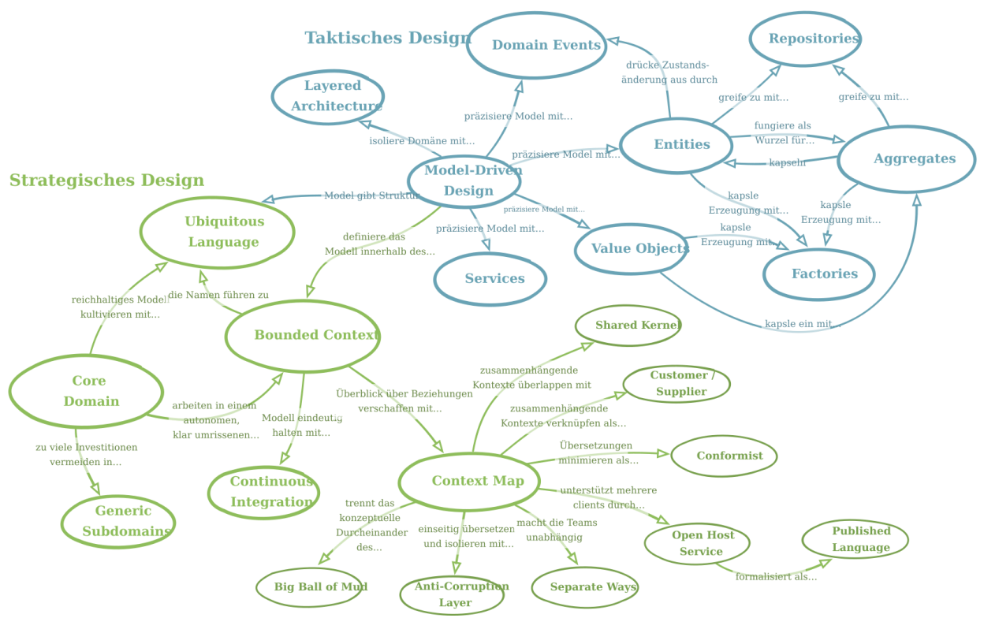
Original by Eric Evans, freely translated by Bastian Nolte

Toolset
Version management / SCM | Git, Atlassian Bitbucket (Bitbucket, Stash), Liquibase (Database Refactoring), Github, GitLab
Test automation | Jest (JavaScript testing framework), Cypress (JavaScript End to End Testing Framework), JUnit, xUnit.net, TestNG (Testing Framework), Mockito, EasyMock, PowerMock, Hamcrest, DbUnit, H2 Database Engine (H2), Arquillian, Arquillian ShrinkWrap (ShrinkWrap), Arquillian Drone, Arquillian Graphene, Selenium, Selenium Grid (Grid), Karma Test Runner (Karma), Jasmine Modultest-Bibliothek (Jasmine), Protractor end-to-end test framework (Protractor), $httpBackend, SonarQube, SoapUI, Postman, FindBugs™, Lint, Jest Snapshots (Jest Snapshot Testing), Pester (PowerShell testing framework)
Build Tools | Gradle Build Tool, Apache Maven (Maven), Jenkins (Hudson), Jenkins Pipeline, TeamCity CI/CD, npm, Gulp (gulpjs, workflow automation and enhancement), Bower (package manager), Docker, Yarn - Package Manager, JRebel, Biome (Biome linter, Biome formatter), GitHub Workflows/Actions, JFrog (JFrog Platform, JFrog Artifactory), Mend Renovate (Renovate, Renovate Bot), pnpm, TSLint, Vite
Coordination / Support | Atlassian Jira Cloud (Jira), Atlassian Jira Server (Jira), Tempo für Jira, Microsoft Project, HP Application Lifecycle Management (HP ALM)
Documentation | Adobe Framemaker, Atlassian Confluence (Confluence)
Prototyping | Adobe XD, Figma
Projektarchitektur | SparxSystems Enterprise Architect (Enterprise Architect), Microsoft Visio Professional, OmniGraffle
Microsoft Office | Microsoft Word, Microsoft Excel, Microsoft PowerPoint
SAP | SAP CRM (Customer Relationship Management), SAP ERM (Enterprise Resource Planning, Finance, Human Resources, Manufacturing, Logistics, Services, Procurement), SAP CATS
Logging, monitoring and reporting | Splunk, Grafana

Design Patterns & Principles
Architectural pattern | Atomic design, Model view controller (MVC), Model view presenter (MVP), Event-driven architecture, Service-oriented architecture (SOA), Command query responsibility segregation (CQRS), Enterprise architecture, Publish–subscribe pattern, PRPL pattern (Push (or preload), Render, Pre-cache, Lazy Load)
Analysis pattern | Domain driven design (DDD), Event sourcing (ES)
Creational design pattern | Singleton pattern, Prototype pattern, Factory method, Builder pattern
Structural Design Pattern | Adapter pattern, Composite pattern, Decorator pattern, Proxy pattern, Facade pattern, Bridge pattern, Data Access Object (DAO), Data Transfer Object (DTO)
Behavioral Design Pattern | State pattern, Strategy pattern (policy pattern), Visitor pattern, Memento pattern (Token pattern), Observer pattern, Null object pattern, Circuit breaker pattern
Concurrency pattern | Double-checked locking, Thread pool pattern, Readers–writer lock
SOLID principles | Single responsibility principle, Open–closed principle (OCP), Liskov substitution principle (LSP), Interface-segregation principle (ISP), Dependency inversion principle (DIP)
Distributed computing | Saga Transaction Pattern (Saga distributed transactions), Throttling pattern, Static content hosting pattern
Sharding Pattern | Range-based sharding pattern, Vertical Sharding Pattern, Hash-based Sharding

Unix server management
Operating systems | Debian GNU/Linux (Debian), Red Hat Enterprise Linux (RHEL), Fedora, OpenBSD
Services | Apache HTTP Server, Apache Tomcat® (cluster) (Tomcat), SonarQube, Jenkins (Hudson), Squid Cache & Proxy Server (squid), Postfix (Mail Transfer Agent, MTA), Exim Internet Mailer (Exim), Cyrus IMAP, AMaViS (A MAil Virus Scanner), Clam AntiVirus (ClamAV, clamd), OpenLDAP (LDAP), MIT Kerberos-Server  , free RADIUS (RADIUS, Remote Authentication Dial-In User Service), DansGuardian, ProFTPD (Highly configurable GPL-licensed FTP server software), Apache SpamAssassin, Samba File- & Print Server (smb, cifs), DHCP daemon (dhcpd), BIND Nameserver (bind, DNS Server), Network Time Protocol Deamon (ntpd), Pluggable Authentication Modules (pam, pamd), Network File System Deamon (nfs), iptables, Simple Network Management Protocol Deamon (snmpd), SNORT (Network Intrusion Detection System, Network Intrusion Prevention System, NIDS, NIPS), Nagios (The Industry Standard In IT Infrastructure Monitoring, IT Infrastructure Monitoring), Kerberos, Nginx

Professional Development
Regular further education is the foundation of in-depth expertise. Therefore, I am constantly training myself, primarily using the possibilities of the World Wide Web. You can find a list of the most recent further education courses in the following table.
Year | Type | Organiser
2026 | Microsoft Azure Zertifizierung (ongoing)  - AI-901: Microsoft Azure AI Fundamentals | Microsoft, Pearson VUE
2026 | Anthropic Academy (ongoing)  For details see: https://bastian-nolte.name/en/resume/#professional-development | Skilljar (Anthropic)
2021 | Apache Kafka Course  4929: Confluent Training «Apache Kafka Fundamentals» | Confluent
2021 | Microsoft Azure Certification  - AZ-900: Microsoft Certified Azure Fundamentals (https://bastian-nolte.name/link/cert/ms-az-900) | Microsoft, Pearson VUE
2020 | Kubernetes Certification  - LFS158x: Introduction to Kubernetes (https://bastian-nolte.name/link/cert/lfs158x) | The Linux Foundation, edX
2020 | DevOps Kubernetes Camp  - Four-day intensive training on Kubernetes and Knative. | Software & Support Media  Erkan Yanar
2019 | Conflict Management and Constructive Conflict Resolution | oose Innovative Informatik  Kim Duggen
2019 | Communication & Moderation Techniques in IT | oose Innovative Informatik  Tina Busch
2019 | Certified iSAQB-Modul «Advanced Level DDD»  - Domain-Driven Design at the Software Architecture Camp | Software & Support Media  Matthias Bohlen
2019 | Certified LeSS Basic Training | Valtech GmbH  Nils Bernert
2018 | w-jax  For details see: https://bastian-nolte.name/en/resume/#professional-development | Software & Support Media
2018 | Jax Agile Day 2018  For details see: https://bastian-nolte.name/en/resume/#professional-development | Software & Support Media
2018 | JavaScript- & AngularDays  For details see: https://bastian-nolte.name/en/resume/#professional-development | Software & Support Media

Usage of this Curriculum Vitae
This Curriculum Vitae is publicly available for download at the web address https://bastian-nolte.name/en/resume. Forwarding this resume to a potential client - for example, by a recruiter or a temporary employment agency - does not constitute the initiation of a placement. Any modification or adaptation of this CV, including excerpts, requires my permission. The use of this CV or extracts thereof for any purpose other than initiating an assignment requires my written authorisation.

